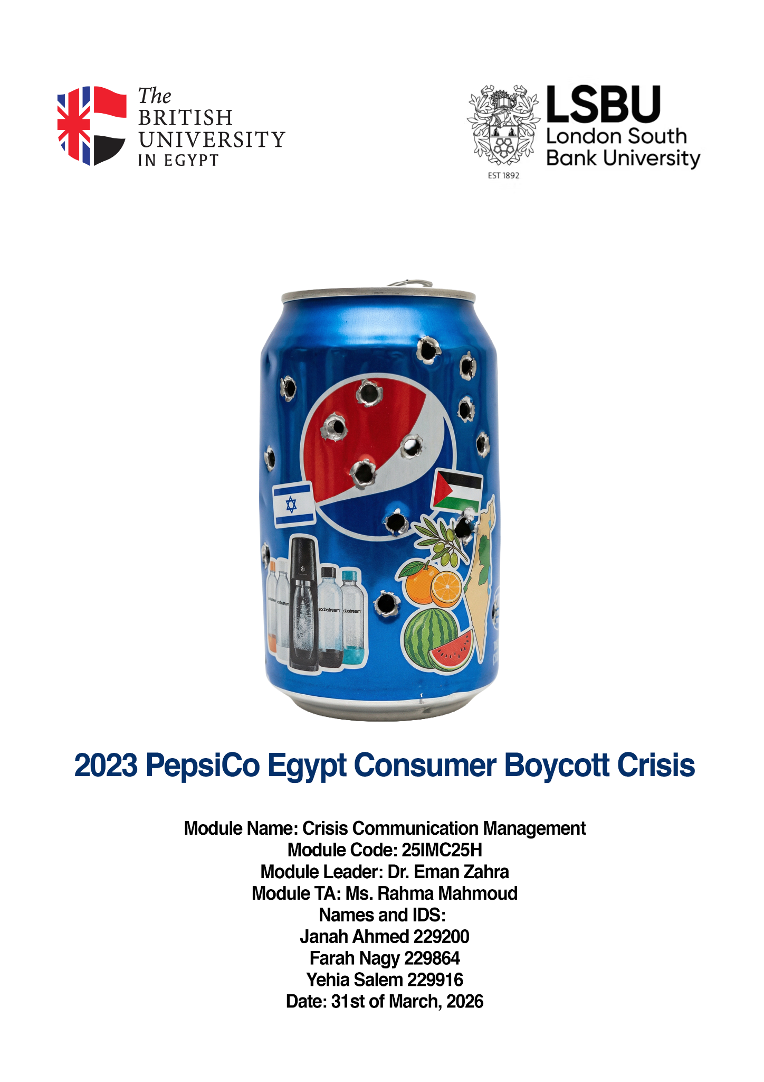

1. Introduction

In our modern era of globalism and hyper-connectivity, the marketplace is no longer a neutral ground of simple, basic transactions. It is a profound battleground of moral values, human solidarity, and expressions of cultural identity. All the same, when geopolitical issues fracture the fragile peace of nations, the ripples extend way beyond borders, confining multinational corporations into a state of reckoning with their own socio-political footprint.

This paper explores one major event of this scale: the devastating 2023 consumer boycott of PepsiCo in Egypt. PepsiCo, an unstoppable giant in the global food and beverage industry, with a long-lasting history in the Egyptian market through beloved local brands like Chipsy (PepsiCo, Inc., 2023), found itself confined in an existential crisis unlike any other following the tragic escalation of the events on October 7, 2023, in Palestine.

For Egyptian consumers, a population bound by its profound historical and religious solidarity with Palestine, purchasing a can of Pepsi ceased to be a simple transaction, but rather became an active message to the world endorsing the company's ties to Israel. This cultural shift, guided by an unprecedented wave of digital activism on all social media, triggered a massive decline in PepsiCo's local sales.
This comprehensive case study seeks to methodically dissect PepsiCo's Egypt crisis communication management during this tumultuous period by employing a robust secondary analysis through the use of PESTLE (Political, Economic, Social, Technological, Legal, Environmental) and SWOT (Strengths, Weaknesses, Opportunities, Threats) frameworks in tandem with primary survey research gauging the attitudes of the young Egyptian public. This paper will illuminate the severe shortcomings in the company's initial strategy. Furthermore, it will propose a forward-looking action plan, mapping a path through the crisis management matrix to guide how corporations can navigate the deeply wound, intricate emotional depths of socio-political crises in an increasingly globalized and volatile world.

2. Secondary Analysis
2.1 Situational analysis
According to Smith (2022), situational analysis is often defined as the process of investigating an institution’s current situation by examining its customers, competitors, strengths, weaknesses, and industry trends. Situational analysis allows companies to make insight-driven decisions and develop marketing strategies.

2.2 Macro Environment — PESTLE
The macro-environmental landscape (the larger environment in which the brand and crisis resides) during the 2023 PepsiCo Egypt boycott crisis can be monitored using the PESTLE framework to understand the external pressures driving the conflict.

- Political:
Egypt has a highly centralized autocratic government and has maintained a public stance of neutrality during the 2023 civilian boycott, neither standing against it nor with it, despite mounting pressures from within civilian communities and movements of solidarity with the Palestinians concerning the Israeli-Palestinian conflict (U.S. Department of State, 2023). Following the events of October 7th, there was immediate backlash from Arab communities throughout the Middle East and worldwide against Western or perceived Western or pro-Israel brands. PepsiCo got caught in this group of boycotted brands due to its acquisition of SodaStream in 2018 for $3.2 billion and its equity partnership with the Strauss Group, co-owners of Sabra Hummus. These ties were heavily promoted, and boycotts were heavily encouraged across Arab social media and national media (Al Jazeera, 2023; BBC News, 2018).

- Economic:
2023 marked a difficult year for the Egyptian economy as the nation was experiencing an inflation rate of 11%, a recently re-de-valued Egyptian pound, and an unemployment rate of nearly 6.9% (International Monetary Fund [IMF], 2023; World Bank, 2023) With significant impacts on per capita purchasing power, consumers who are already economically strained found it easy to replace PepsiCo products with local alternatives, many of which were significantly cheaper. This placed PepsiCo in a financially vulnerable position.

- Social:
Egypt's demographic distribution of 106 million people leans heavily towards a younger, digitally native population due to the high birth rate (Kozinets & Handelman, 2004). With a deep intrinsic solidarity for the Palestinian cause and years of anti-Israel messaging pushing them further, the boycott rapidly transitioned into a matter of cultural and national identity, promoted by community leaders, influencers, and widespread word of mouth. At this point, if you weren't boycotting, you were the enemy.

- Technological:
With internet penetration in Egypt reaching approximately 72%, social media platforms (WhatsApp, TikTok, Facebook, X) acted as immediate accelerators for the boycott. Decentralised boycott lists went viral within hours, placing PepsiCo's initial incident response team in an immediate, reactive crisis that needed to be addressed immediately (Babatunde, 2022).

- Legal:
Egyptian law does not prohibit voluntary consumer boycotts. Despite the ongoing treaty with Israel, this does not extend into purchasing decisions of the everyday person. Consequently, PepsiCo had no legal channel to resort to to stop the messaging against its products, remaining only subjected to standard corporate operations covered by the Investment Law 2017 and Companies Law 2018 (U.S. Department of State, 2023).

- Environmental:
This concern is secondary to the political crisis; however, PepsiCo routinely faces criticism regarding its incredible plastic footprint and agricultural water usage within a nation that is heavily water-stressed. Due to the recent GERD situations with Ethiopia restricting water inflow to the nation, creating whiplash reputational vulnerability, latent in nature, that activists occasionally leveraged during the boycotts to further their messaging (Segran, 2019).

2.3 Micro Environment — Company Background
Micro-environment can be defined as the factors close to an institution that directly affect its ability to serve its consumers and achieve its objectives. In other words, anything that the company interacts closely with the business and affects strategic decisions, such as the institution itself, its competitors, customers, suppliers, and publics ( Kotler & Armstrong, 2017).

History: Through the merger of Pepsi-Cola and Frito-Lay, PepsiCo was founded in 1898. PepsiCo is considered to be the world’s leading food and beverage company, operating in more than 200 countries worldwide, including South Asia, the Middle East, and Africa. (PepsiCo Annual Report, 2023). PepsiCo is the mother company of major brands such as 7 Up, Pepsi, Lay’s, etc. In addition, over the years, PepsiCo has acquired several other famous brands such as Tropicana, Gatorade, and Quaker Oats, strengthening its position even more in the market (FoodTalks, 2024).

Products in Egypt: The products that PepsiCo distributes in Egypt include drinks such as Pepsi, Mirinda, 7 Up, Aquafina, and snacks like Cheetos, Doritos, and Chipsy. These products are localised in Egypt, and they are considered the dominant leaders in the market.
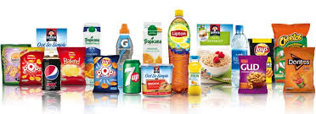

Marketing Mix: The products that PepsiCo offers include a variety of drinks and snacks such as Pepsi, 7 Up, and Lay’s. Additionally, the corporation emphasizes innovation by creating new flavours and sugar-free options. As for the price, PepsiCo offers different prices and packaging sizes to align with the different needs of the target audience. In order to sustain a strong competitive edge, it applies competitive pricing against its competitors, such as Coca-Cola.
Moreover, for the place, PepsiCo functions across various restaurants, grocery stores, kiosks, and online platforms. Lastly, the promotion that PepsiCo uses various advertising techniques such as celebrity endorsements, jingles, and sponsorships, specifically sports, in order to maintain its energetic brand identity.
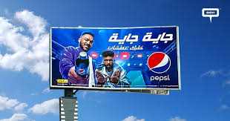

Positioning: PepsiCo's positioning focuses on being an innovative and youthful brand. It highlights affordability, product diversity, and ongoing improvement. It also emphasizes healthier options and sustainability to reinforce its brand image.
Competitors: The main competitor of PepsiCo is the Coca-Cola company. As for the Local Egyptian brands, the competitors are Spiro Spathis, V7, and Maxi. 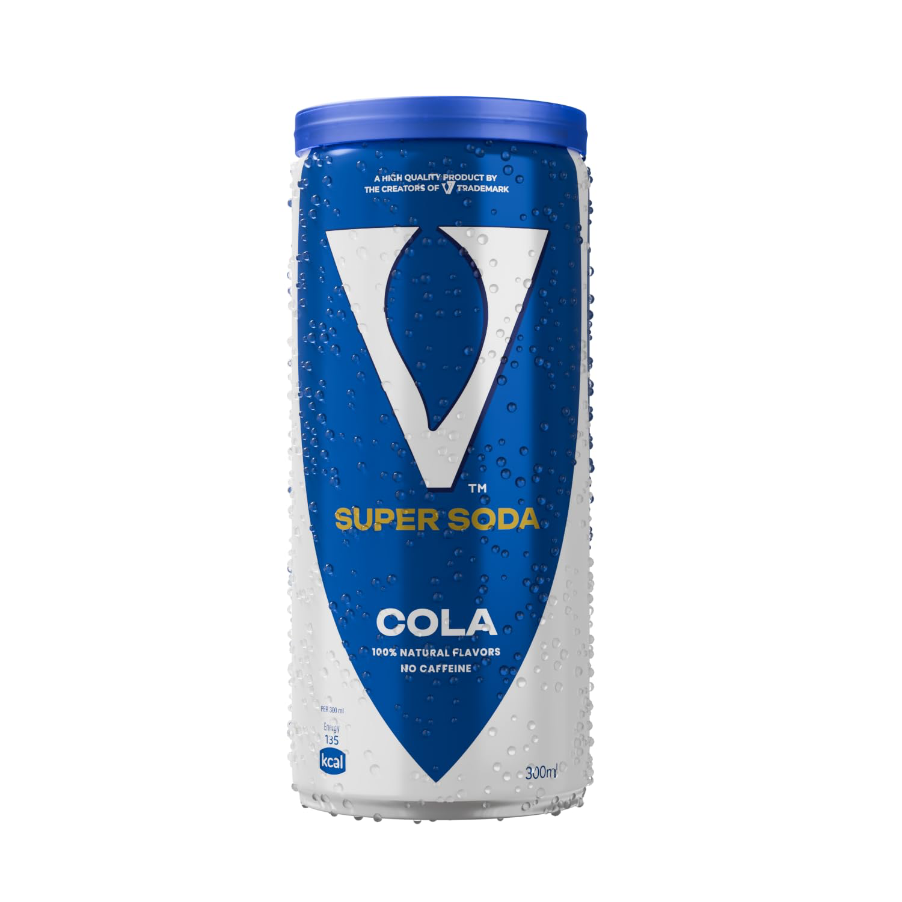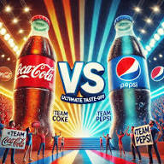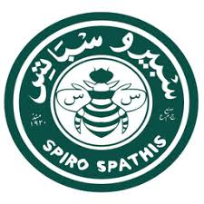

2.4 Crisis History and Previous Crisis Strategies
1. Pepsi Number Fever in the Philippines:
PepsiCo has been through many crises in its past. Starting with the 1992 “Pepsi Number Fever", also known as "the 349 incident” case in the Philippines. The incident occurred when PepsiCo offered cash prizes for numbers under the bottle caps of their beverages. On May 25, the grand-prize winner number was 349, however, an error in the production occurred and around 800,000 caps displayed the number bought without the security code required. Many consumers thought they had won, when in reality they did not. As a result, they held protests, boycotts, and violent incidents occurred which led to property damage and the death of five people. This incident became one of the most widely known marketing failures in history (Pulos, 2020).

PepsiCo’s Response:
Back then, Pepsico didn’t cleverly handle the crisis; it refused to honour the claims of people who had rights, claiming that there were no security codes in the bottles; therefore, they couldn’t pay them their earned prize. Instead, they announced that they can only give people a small amount as compensation, which is 500 pesos. Some people accepted the token, but others refused and protested against the company. The company faced many protests and thousands of lawsuits as the public was outraged that Pepsico couldn’t fulfill their promises of the competition, and they only gave out this small amount of money to shut the public's mouth and enhance their public image (Pulos, 2020).
2. India’s Pesticide Incident
Similarly, another incident occurred in India in 2003, known as the “Pesticide Controversy”, where many people reported that the beverages had residues of pesticides, with levels around 30 times above the recommended limits. After testing, toxic chemicals were found in samples of Pepsi products, which triggered significant public concern regarding the health risks of consumption. As a result, the controversy turned into a national concern, tarnishing the company’s reputation (CSE, 2003, as cited in Journalism University, 2025).

PepsiCo’s Response:
As a response, PepsiCo denied all the accusations, directly challenging the credibility of the CSE’s testing methods and assuring that all its products align with the safety regulations and standards of India. The company held a press conference rejecting all the allegations and even threatened to take legal actions against the watchdog group. It also focused on showing its internal testing that follows the guidelines before distributing them. Despite the efforts, the incident had an ongoing impact on the company's image and safety standards (CSE, 2003, as cited in Journalism University, 2025).

3. Can-Tempering Rumours:

In the United States, during 1993, PepsiCo faced a major crisis where many reports surfaced, claiming that foreign objects such as syringes and needles were found inside the cans of the beverages sold. Rumours quickly spread across the media, creating panic amongst consumers who believed the products were unsafe for consumption. Rumors spread rapidly through the media and public channels, creating alarm among customers who feared the products were unsafe and led to heightened examination of PepsiCo’s safety procedures. The situation rapidly escalated, as the media coverage instilled fear among the public, which increased the pressure on the reputation of the company, since product tampering is a major threat any brand can experience (Edubirdie, 2026).

PepsiCo’s Response
According to Edubirdie (2026), PepsiCo distributed videos that showed how the canning of the beverages is done to show that it would have been impossible for the products to be tampered during the process. Moreover, surveillance footage was obtained from a store, showing individuals inserting syringes inside the cans prior to the purchase. This debunked all the claims that were held against the company, and therefore, regained the trust of the public.

2.5 SWOT Analysis
To formulate actionable recommendations, it is critical to evaluate PepsiCo Egypt's internal capabilities against external market realities.

 | Helpful (to achieving the objective) | Harmful (to achieving the objective)
Internal (attributes of the organization) | STRENGTHS  • Brand Equity & Distribution: Strong cultural heritage through localized brands like Chipsy, reaching over 200,000 retail outlets nationwide, many of which are local kiosks and markets.  • Financial Resilience: Backed by global parent company liquidity, PepsiCo was able to absorb temporary decreases in sales volume without much effect to stakeholders (PepsiCo, Inc., 2023).  • Economic Contribution: Major local employer, which serves as a powerful narrative of Egyptian job creation and agricultural sourcing.  • Broad Product Portfolio:Offers a diversified range of beverages and snacks, insulating overall revenue from boycotts targeting only one specific product line. | WEAKNESSES  • Corporate Affiliations: Direct, well-documented structural ties to Israeli corporations (SodaStream, Strauss Group) which directly contradict the values of the boycotting demographic . PepsiCo has direct paper trails that indicate structural ties to Israeli corporations, so does Stream Strauss Group, which, although indirectly, supports the IDF, thereby contradicting the values of the boycotting demographic (BBC News, 2018).  • Communication Agility: Bureaucratic corporate structure restricts quick, culturally motivated crisis communication.  • Cost Structures:  Reliance on imported raw materials, such as concentrates, combined with a devalued local currency, creates stress on profit margins.  • American Brand Identity: Perceived as an inherently American corporation, making the brand an automatic target during periods of heightened anti-Western geopolitical sentiment in the region.
External (attributes of the environment) | OPPORTUNITIES  • Re-localization Campaigns: Investing in the Egyptian identity through CSR, local investments in agriculture, and specifically tailored culturally compliant marketing (Smith, 2018).  • Digital Commerce Expansion: Making use of direct-to-consumer digital channels to bypass traditional visible retail boycott pressure points (i.e., Talabat Mart, Carrefour), skipping the consumer seeing others boycott thereby boycotting themselves.  • Product Innovation: Developing and launching highly localized, exclusive Egyptian product variants and packaging to regain consumer interest and re-establish a cultural connection.  • Strategic Local Partnerships: Collaborating with beloved domestic Egyptian brands, civic organizations, or charities to rebuild goodwill and distance local operations from global politics. | THREATS  • Sustained Boycott Institutionalisation: The temporary boycott may morph into a permanent negative shift in consumer behavior towards the brands.  • Local Competitors: Rivals such as Spiro Spatis, V-Cola, Maxi-Cola, and others are capitalizing on the gap present in the market, rapidly scaling up their distribution and capturing the low-price market segment permanently.  • Social Media Resurgence: There persists a constant risk of new viral campaigns rekindling outrage even with minimal provocation.  • Macroeconomic Instability: Prolonged inflation, continued currency devaluation, and rising operational costs in Egypt threatening long-term profitability and pricing stability.

3. Primary Research

3.1 Survey (Method, Size, Procedures)
A quantitative research method was applied using a structured survey to collect data. The survey aimed to gather insights and information from people regarding the PepsiCo 2023 boycott crisis. The survey included multiple types of questions, such as assessment, awareness, evaluation, and demographic. Additionally, the survey was sent via WhatsApp and email, and it managed to achieve a total of 57 responses. After collecting the data, the survey’s findings were critically analysed as follows:

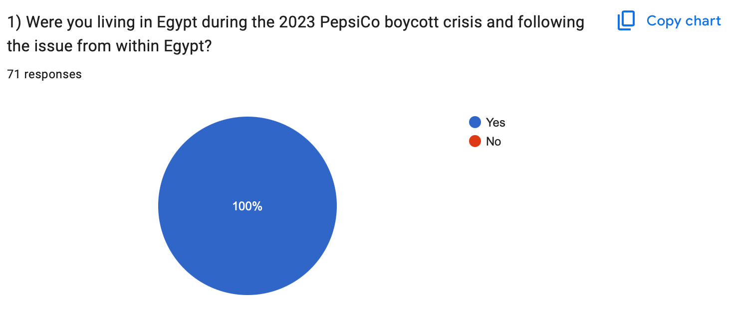

All of the survey participants were living in Egypt during PepsiCo’s boycott crisis, which makes their responses credible.

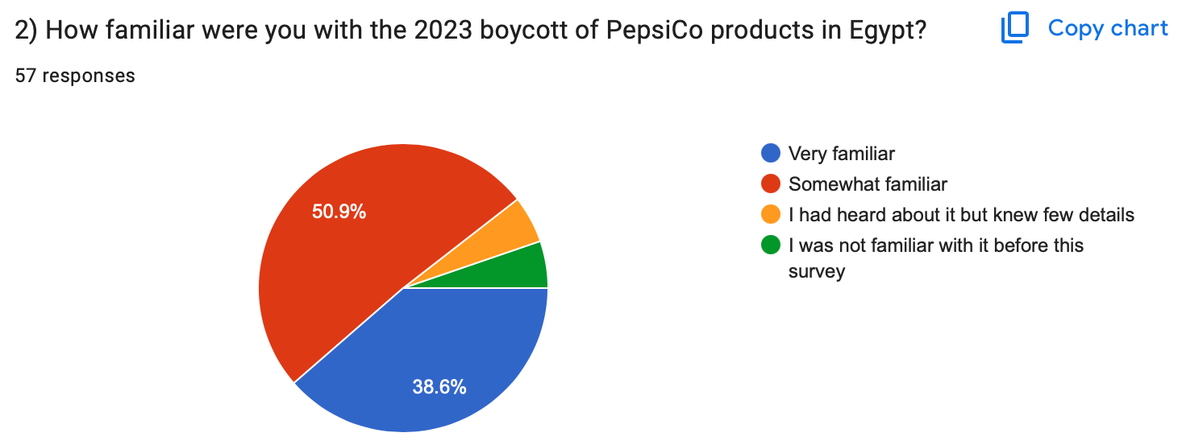
It is shown that 50.9% of the respondents were very familiar with the boycott which indicates that it received significant public attention, suggesting a strong effect on the consumers’ awareness.

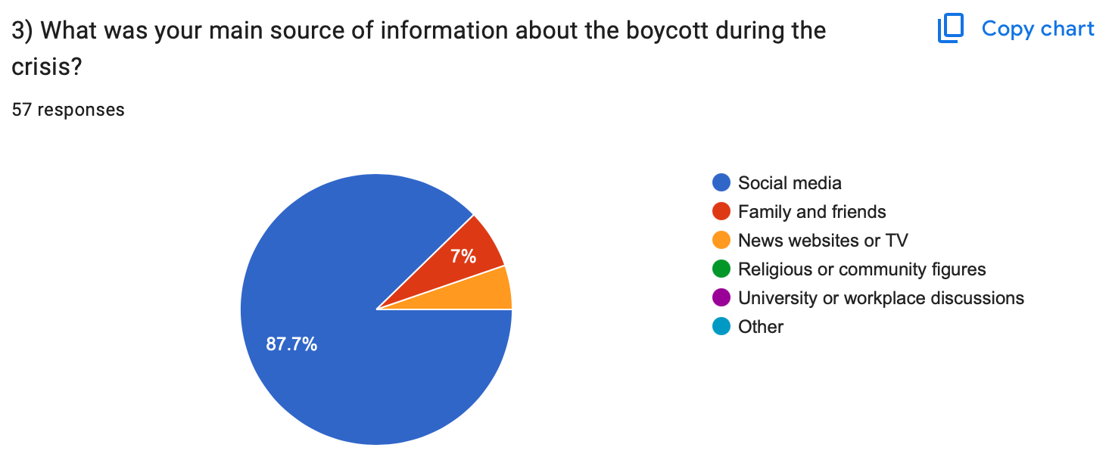

It was found that 87.7% of the participants received their information from social media, which indicates that online platforms were very influential in shaping public knowledge of the boycott.

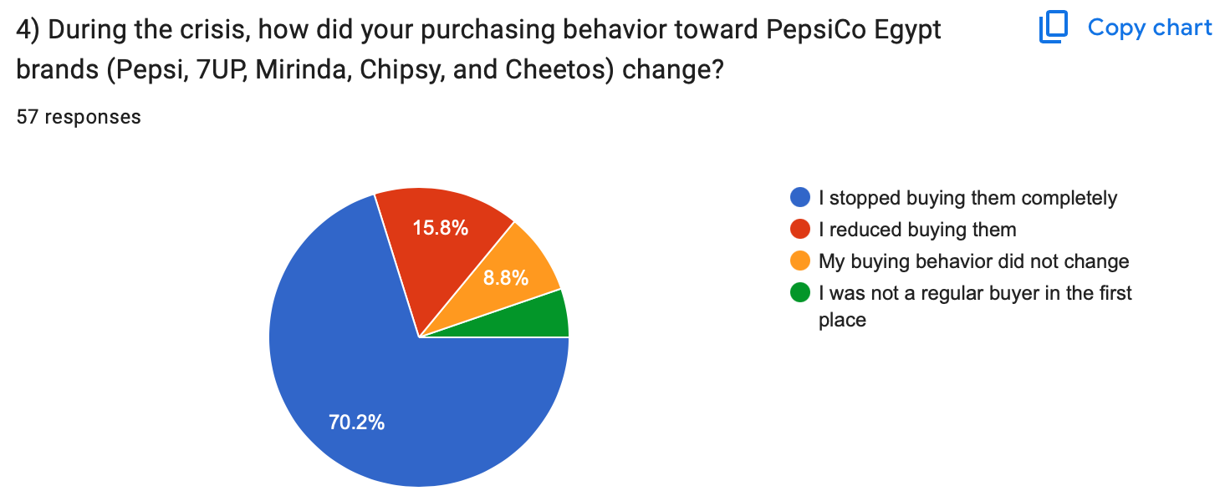
It was found that 70.2% of the participants completely stopped purchasing any of PepsiCo’s products, showing a strong behavioural response to the boycott and that the issue severely shifted their buying behaviours.

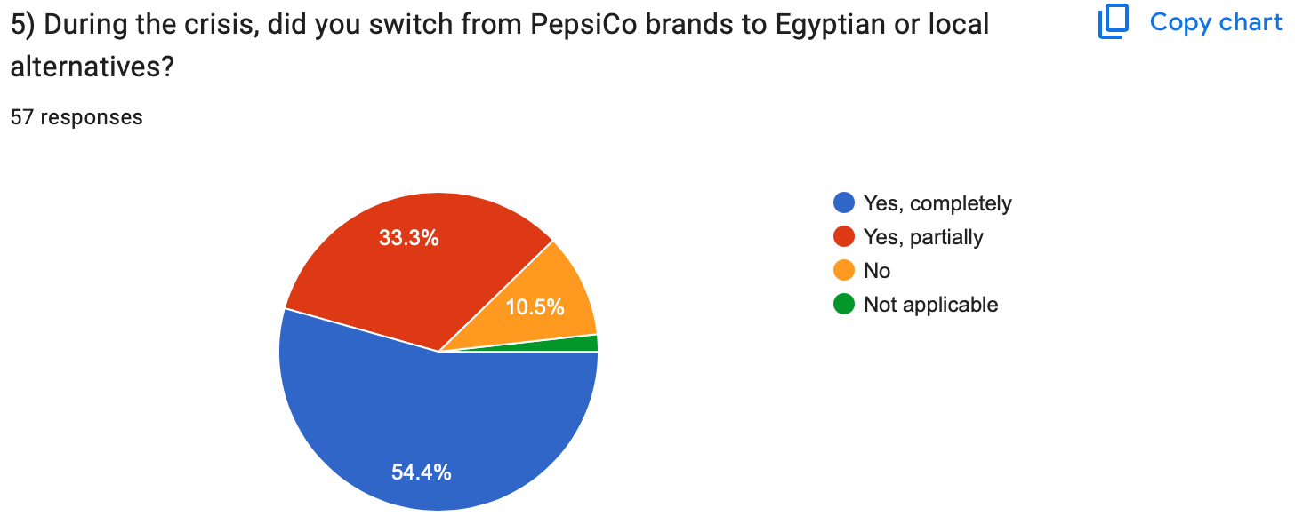

It was found that 54.4% of the survey respondents switched to local alternatives, showing that the boycott did not only lead to PepsiCo’s products not being purchased, but it also encouraged support for local alternatives.

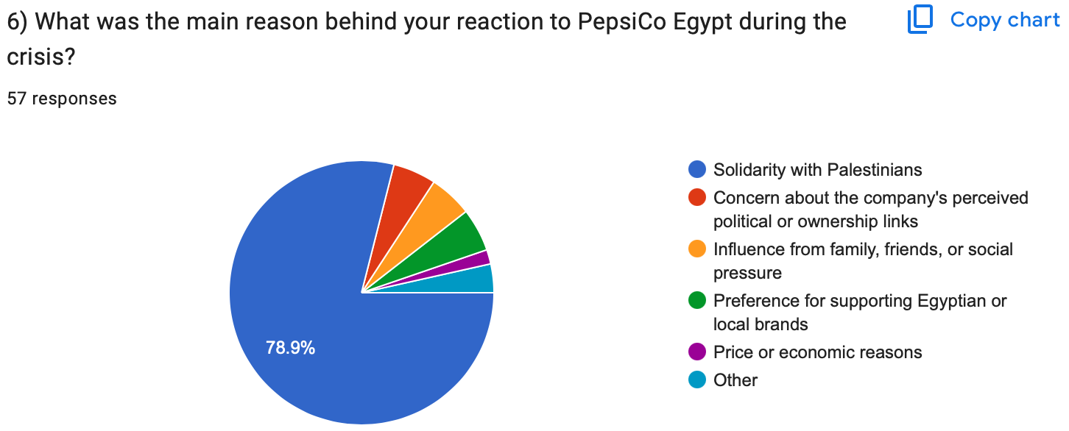
It was found that 78.9% of the participants boycott PepsiCo out of solidarity with Palestinians, which shows that it was shaped by political and ethical motivations, not for other reasons.

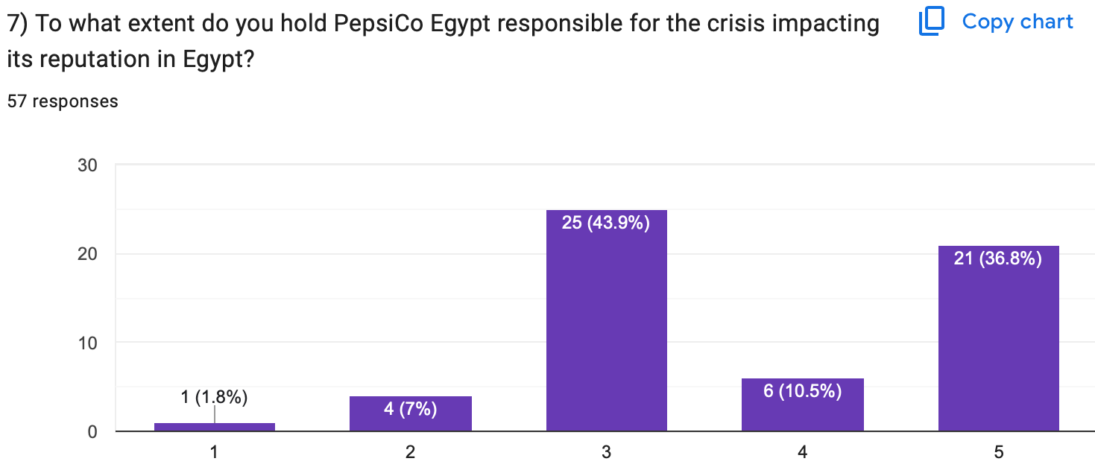
The survey responses show that many hold PepsiCo accountable for the reputational crisis, with 43.9% rating moderate responsibility, 36.8% rating full responsibility, and only 1.8% rated no responsibility.

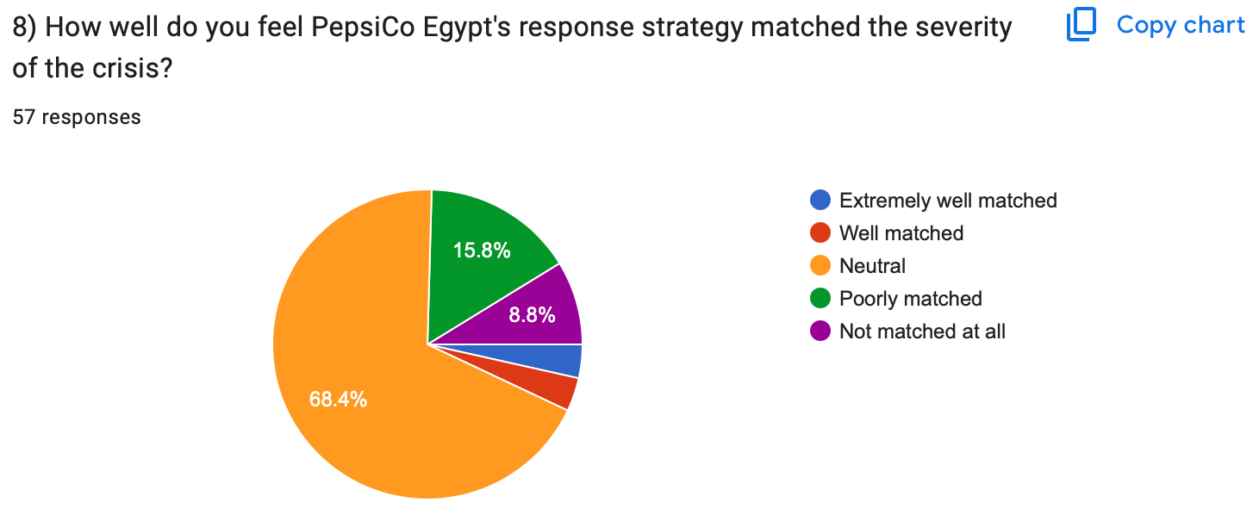

It was shown that most of the respondents (68.4%) saw that PepsiCo’s response was neutral in comparison to the severity of the crisis, while smaller percentages saw that it poorly matched (15.8%) or not matched at all (8.8%). This shows that PepsiCo’s response was generally adequate but was not effective enough when it came to addressing the crisis.

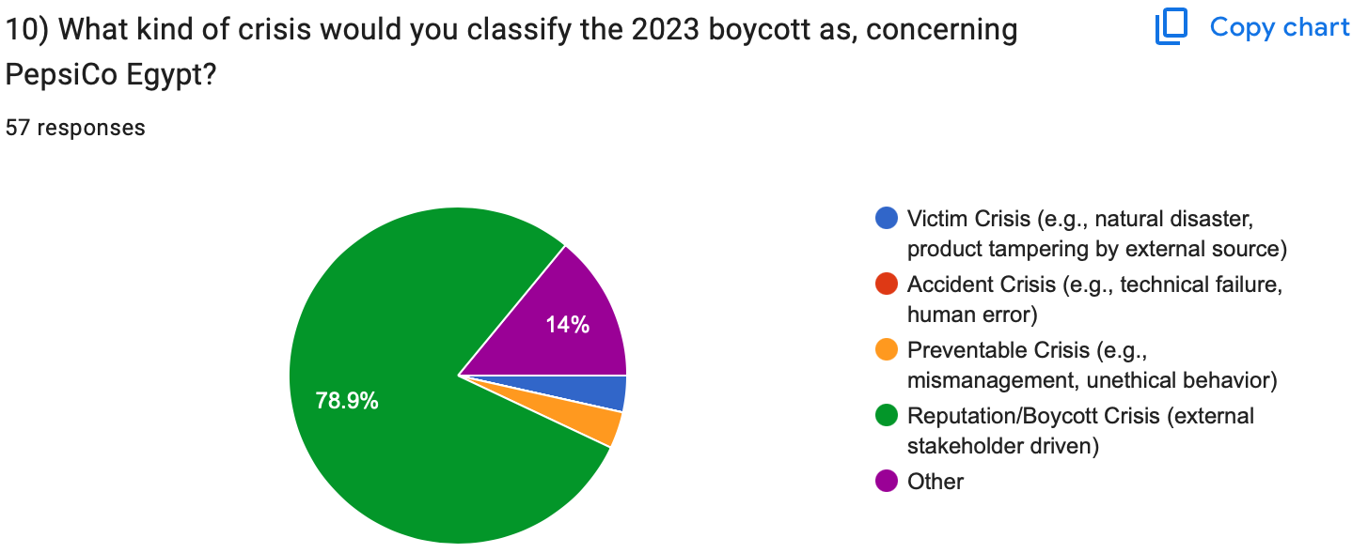
Since 78.9% of the respondents classified PepsiCo’s boycott as a reputation and boycott crisis, this shows that the majority perceived it as a threat to the company’s image, also reflecting that the boycott was motivated by ethical and social concerns.

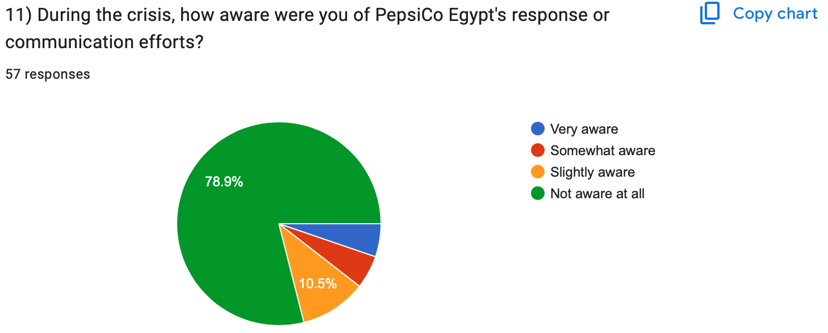
78.9% were not aware at all of Pepsico’s response during the crisis, clearly highlighting the failure of the company to communicate the message or to engage with its audience

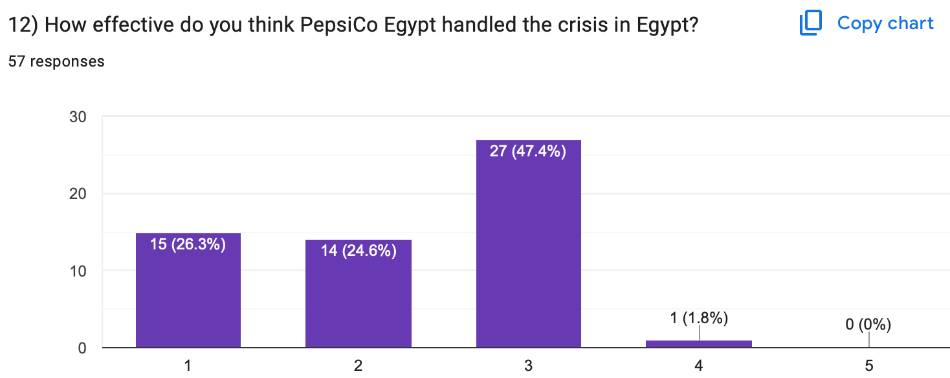
47.4% of the respondents rated Pepsico's handling of the crisis as neutral, while others saw that they were very ineffective, leaving Pepsico with no ratings at all for very effective. It reflects that their way in handling crises and campaigns was rather seen as ineffective.

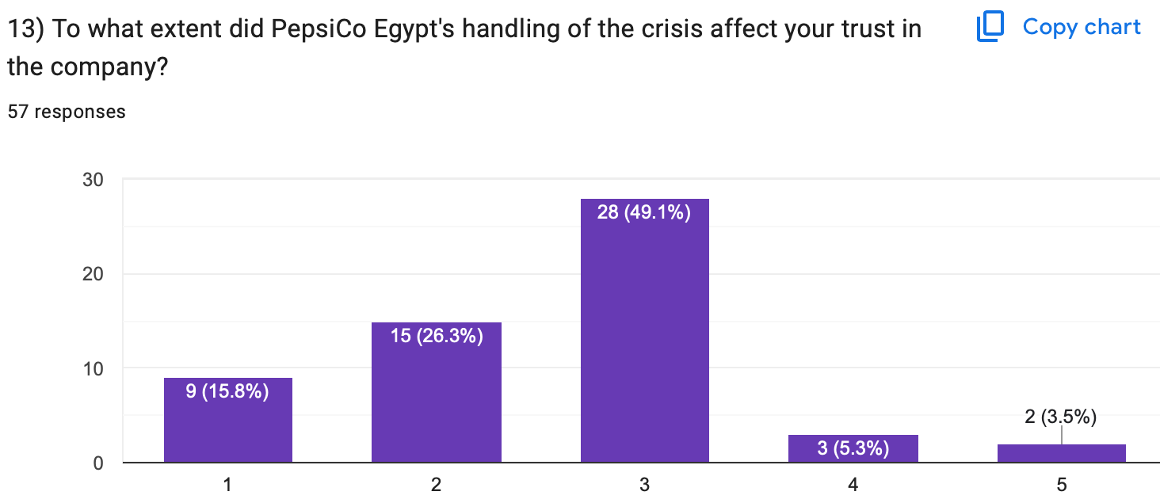
49.1% stated that the company’s way of handling the crisis did affect their trust in the company halfway through

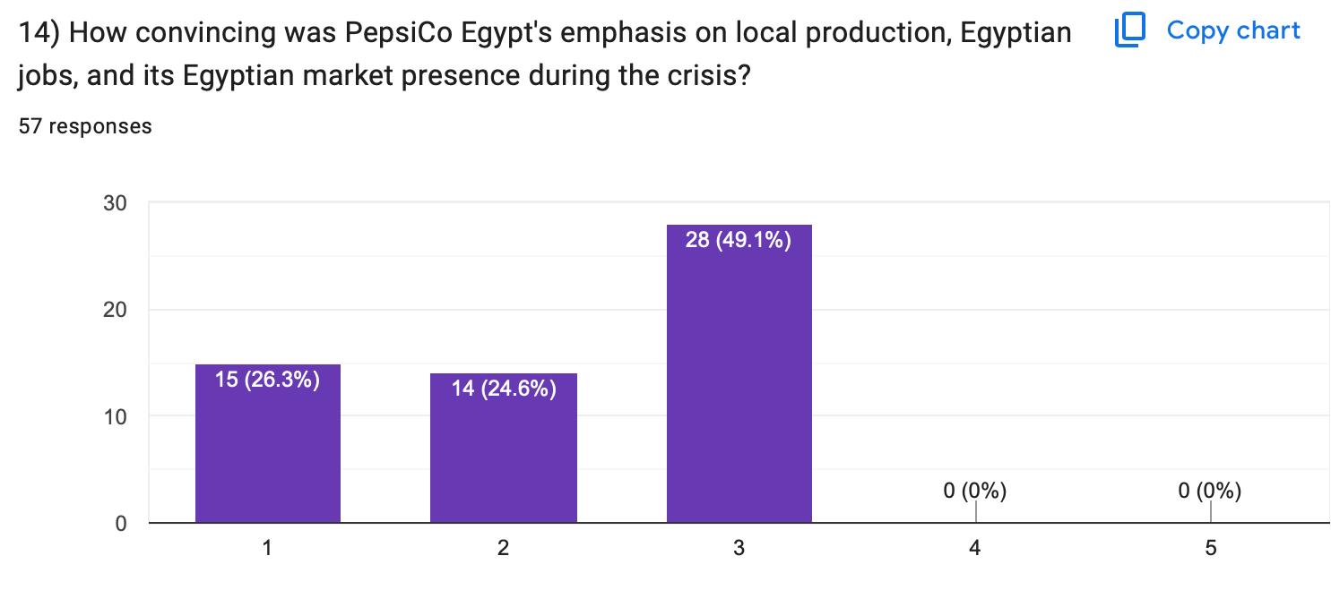
Nearly half of the respondents, 49.1%, were almost convinced of Pepsico’s highlighting and focusing on their local production during the crisis; however, 0% choose that they were fully convinced.
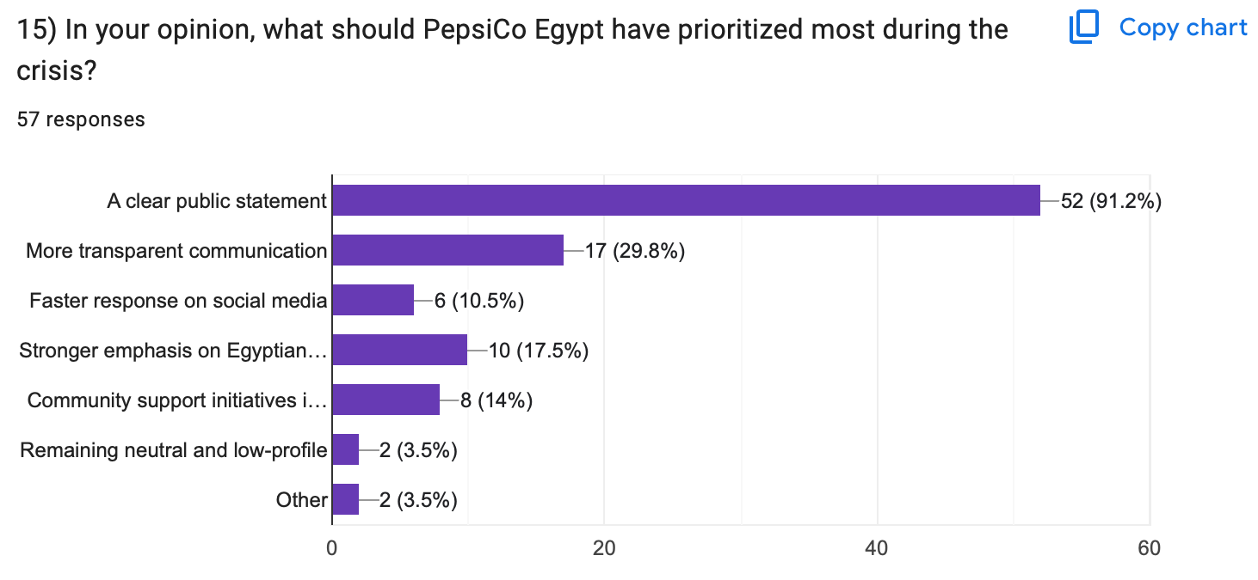
When it came to people’s recommendations about what should have been prioritised by Pepsico during the crisis, the majority of people expressed their desire for a clear and public statement. It clearly shows people’s appreciation and need for transparency within the company and its audience during such a crisis to increase their trust and loyalty.

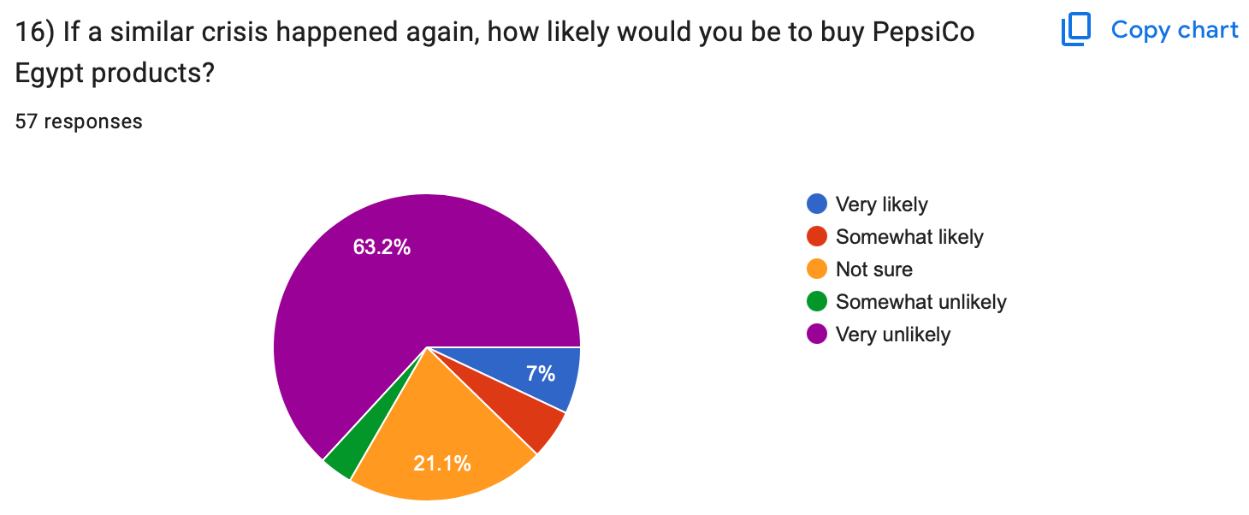
More than half of the respondents declared that if a similar crisis happened, they are very unlikely to buy from PepsiCo again, which strongly highlights that their position towards the company did not change, even with the multiple campaigns and management that PepsiCo did.
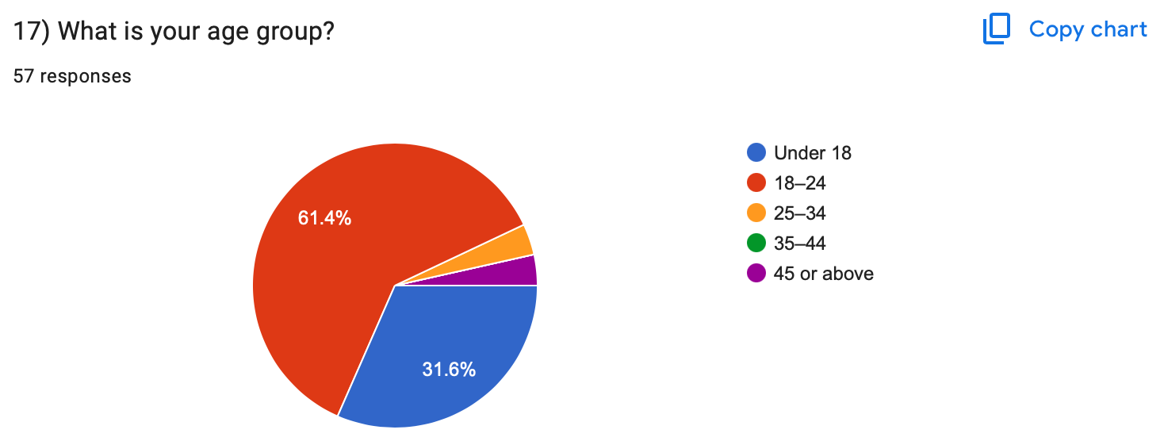
As shown by the survey results, 31.6% were under 18 years, while 61.4% aged from 18 to 24 years, and the remaining were older. It reflects that boycotting took place among all age groups and was not restricted by age, but it was mainly common among youth.
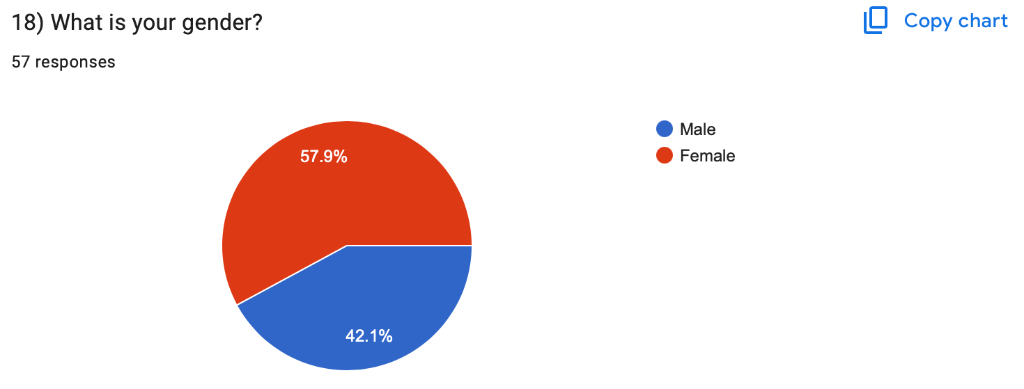

57.9% of the respondents were females while the males represented 42.1%, it shows that participation in boycott took place among both genders and widely spread.
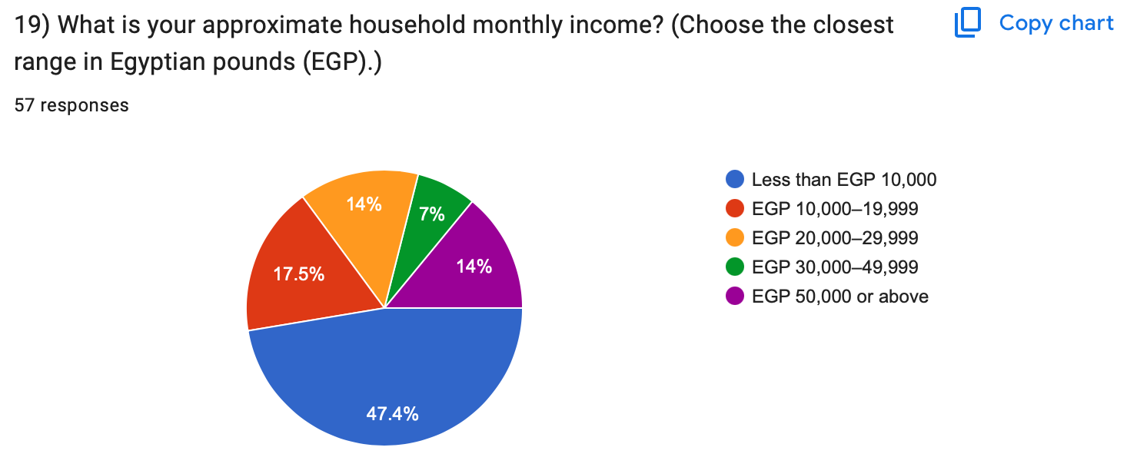
Nearly half of the respondents’ income, which is 47.4%, is over 10k per month, while people with high income are also present and represent 14% of the respondents. It indicates that the boycott was not driven by economic factors but emotional ones

4. Recommendations and Action Plan
4.1 Shortcomings
According to the survey results, three main key points were detected and highlighted as shortcomings of PepsiCo.

First: Strategy misalignment
The responses highlighted that the boycott was emotionally driven due to solidarity with Palestinians; they stopped purchasing from PepsiCo as they saw that it is a company that supports Israel. PepsiCo's response focused on economic factors, as well as being locally made, while ignoring the main issue of the public and totally neglecting their emotions. PepsiCo's response was rational rather than emotional; they didn’t state anything related to the political issue, and this fuelled the Egyptians' feelings and reduced the effectiveness of PepsiCo’s campaign towards the crisis.
Second: Communication failure
Failure to communicate when it comes to the reach and visibility was clearly evident through the responses of the participants, as the majority of them lacked awareness of PepsiCo’s response to the issue at hand. This shows that Pepsico failed to effectively utilize the channels where its audience was most engaged, specifically social media. In crisis management, a well-designed response becomes ineffective and useless if it fails to reach stakeholders. Therefore, during times of crises, utilizing the right platforms and implementing speed, clarity, and strong distribution is crucial to guarantee that the message is well-communicated.
Third: Lack of Transparency
Survey respondents emphasised that PepsiCo’s response strategy lacked transparency and clarity. It is shown that communication was delayed, vague, and indirect, which postponed the stakeholders’ understanding of the issue. As a consequence, it did not only affect PepsiCo in the short term; it also created long-term issues as the consumers' trust declined, confusion increased and negative attitudes and misinformation circulated.

4.2 Action Plan

Crisis Management Matrix
The organization's response is structured across the five cyclical phases of the Crisis Management Matrix, addressing operational, psychological, and communication levels during the 2023 boycott.

Level | Phase 1: Prevention | Phase 2: Detection | Phase 3: Alleviate Crisis | Phase 4: Restart | Phase 5: Learning
01 Content / Process | What? Scrutinize brand affiliations (e.g., SodaStream) and heavily monitor geopolitical risks impacting MENA sentiment. | Happen? Public sentiment dropped, immediate consumer boycott, and incredible decline in daily sales. | When? Call upon emergency tax scores immediately upon mass circulation of boycott lists. | Implement recovery strategy, communicating deep Egyptian and Arab market commitment. | Implement continuous round-the-clock geopolitical risk assessments for regional supply chains to ensure this does not happen again.
02 Information | Who? Local PR & Regional Risk Assessment Officers. | Is? Looking out for rapid virality of boycott narratives on social media platforms (TikTok, X). | Collecting? Analyzing real-time sales drops and mapping the primary sources where outrage is voiced on social media | Which? Identifying which local employment and CSR narratives resonate best without seeming defensive. | Information? Compilation of post-crisis case studies to improve organizational guidelines in the future.
03 Organization | Who? Acquiring MENA-specific cultural advisors to search for potential vulnerabilities in brand image. | Is Taking? Local branch managers escalating threat warnings to global HQ in a timely manner. | Over Which? A proprietary cross-functional crisis management team temporarily takes over local operations. | Task? Heads of HR and marketing driving reassurance in consumer minds and internal employee morale and sentiment about the company | And Part? Oversee teams reviewing response timelines to improve speed and efficacy in future crises.
04 Communication | Who? Pre-training local employees on public brand-neutrality protocols. | Will Be? Internal leadership alerted; initial holding statements drafted for immediate release. | When? Issuing empathetic, culturally aligned public statements within 24–48 hours of spike. | Informed? Gradually re-engaging the media with value-driven community initiatives. | And How? Institutionalizing a rapid-response geopolitical playbook for future communications.
05 Psychology | Which Effects? Anxiety within corporate settings over geopolitical exposure, thereby distancing from sensitive affiliations such as Israeli brands in anticipation of the crisis. . | Will be Triggered? Incredible outrage among consumers with solidarity-driven collective action driven by nationalism and pride. | By Event? Avoiding rational, logical, economic defenses which trigger frustration and do not voice concerns, and transferring fully over to empathetic, transparent messaging | Information And? Easing residual anger through sustained investment in local communities without over-branding (i.e., quiet investments in the community) | Action? Changing organizational behavior to validate consumer cultural values which have been deeply held for a long time, ensuring loyalty to the brand

This matrix highlights the transition from identifying the emotional core of the boycotts (Prevention/Detection) to activating a cross-functional structural response (Alleviate), culminating in long-term behavioral changes within the brand's local operations (Learning).

To rebuild stakeholder trust and fortify crisis resilience, the following Action Plan is recommended:

A. Internal Crisis Communication Action Plan
- Establish a Geopolitical Crisis Task Force:
Form a multi-functional local team that comprises PR, legal, and cultural advisors trained to rapidly respond to MENA-specific political sensitivities before seeking lengthy global bureaucratic approvals that may lose time and market share by delaying the communication process (Ulmer & Sellnow, 2014).

- Cultural & Empathy Training:
Conduct regular empathy workshops and scenario planning for all leadership positions of seniority within the Egyptian branch, ensuring that the internal stakeholders understand truly and profoundly the social drivers behind why consumers are acting the way they are.

- Internal Town Halls:
Ensure that different employees who may also feel conflicted working for a potentially damaging corporation to their social beliefs receive transparent communication from those trained leaders regarding the company's stance and efforts to protect both their livelihoods and the livelihoods of people affected. Creating a network of internal brand ambassadors ready to defend the values of PepsiCo.

B. External Crisis Communication Action Plan
- Shift to Value-Aligned Public Statements: Moving away from defensive arguments that have been said time and time again that rely on the economy, such as "we provide jobs” is integral. PepsiCo is in a position where a direct political stance cannot be taken; however, they may acknowledge the emotional distress and human toll transparently and respectfully, without any corporate PR spin.
- Hyper-Localized, High-Visibility Communication: Deploy localized messaging via the channels where the outrage is occurring (e.g., TikTok, X). Use empathetic, Egyptian spokespersons, replacing the traditional faceless corporate press release, thereby creating an emotional bond with the Egyptian public. (Babatunde, 2022).
- Tangible Community Support Initiatives:
Launch highly visible, unbranded humanitarian and community support initiatives, both in Egypt, Palestine, and the rest of the Middle East. Actions speak louder than press releases, and this ensures tangible goodwill within society that cannot be emulated by mentioning the economic statistics of job support that PepsiCo provides in the region.
- Abandoning support for the occupation: Sell SodaStream off and end the equity agreement with Strauss Group, thereby creating a neutral stance where PepsiCo does not directly contribute to the funding of the Israeli occupation but also does not alienate both its buyers in occupied Palestine (Israel) as well as its buyers in the rest of the Middle East.
- Post-Crisis Monitoring (Feedback Loop): Utilize sophisticated social listening tools to detect early signals of recurring boycott sentiments, allowing the Crisis Management Team to preemptively deploy mitigation strategies before they go viral (Sellnow, 2018).

References

Al Jazeera. (2023, November 8). Boycott of US brands in Arab countries. https://www.aljazeera.com

BBC News. (2018, August 20). PepsiCo buys SodaStream for $3.2bn. https://www.bbc.com/news/business-45244759

Case Study of Pepsi Syringe Crisis of 1993. (2022, August 12). Edubirdie. Retrieved March 31, 2026, from https://hub.edubirdie.com/examples/case-study-of-pepsi-syringe-crisis-of-1993/

Coombs, W. T. (2015). Ongoing Crisis Communication (4th ed.). SAGE.

Euromonitor International. (2025, December). Carbonates in Egypt. Euromonitor.

IMF. (2023). World Economic Outlook Database: Egypt. https://www.imf.org

Journalism University. (2025, July 10). The cola pesticide controversy in India: Crisis management and brand defense. https://journalism.university/media-ethics-and-laws/cola-pesticide-controversy-india-crisis-management/

Klein, J. G., Smith, N. C., & John, A. (2004). Why we boycott. Journal of Marketing, 68(3), 92–109.

Kotler, P., & Armstrong, G. (2017). Principles of marketing (17th ed.). Pearson. https://commecsinstitute.edu.pk/wp-content/uploads/2024/08/Kotler-and-Armstrong-Principles-of-Marketing.pdf

Kozinets, R. V., & Handelman, J. M. (2004). Adversaries of consumption. Journal of Consumer Research, 31(3), 691–704.

PepsiCo, Inc. (2022, March 8). PepsiCo suspends Pepsi-Cola brands in Russia [Press Release]. https://www.pepsico.com

PepsiCo’s path to global dominance: From beverage brand to food empire. (2024, November 18). FoodTalks. https://www.foodtalks.cn/en/news/54496

PepsiCo, Inc. (2023). 2023 Annual Report. PepsiCo.

Pulos, R. (2021). Pepsi‑Cola’s Number Fever fiasco: How the media portrays the actors of a crisis. Proceedings of the New York State Communication Association, 2020, Article 8. https://docs.rwu.edu/cgi/viewcontent.cgi?article=1126&context=nyscaproceedings

Reuters. (2019, April 26). PepsiCo sues four Indian farmers. Reuters.

Segran, E. (2019, November 1). Coca-Cola, Nestlé, and PepsiCo are the world's biggest plastic polluters. Fast Company.

Smith, P. (2022). Digital Marketing Excellence: Planning, Optimizing and Integrating Online Marketing (6th ed.). Routledge. https://doi.org/10.4324/9781003009498

U.S. Department of State. (2023). 2023 Investment Climate Statements: Egypt. https://www.state.gov

Wikipedia. (2026, February 24). Economy of Egypt. https://en.wikipedia.org/wiki/Economy_of_Egypt

Wikipedia. (2026, March 2). PepsiCo. https://en.wikipedia.org/wiki/PepsiCo

World Bank. (2023). Egypt Overview. https://www.worldbank.org/en/country/egypt/overview

